|  |  |
| --- | --- |
| garment inventory system |  |
|  |  |
| 3/10/2014 | Group 5 |
| Course no: CSE 308 | **Student id: 1005047,**  **1005051,**  **1005053,**  **1005056 &**  **10050 57** |

garment inventory system

Group 5

ERD:

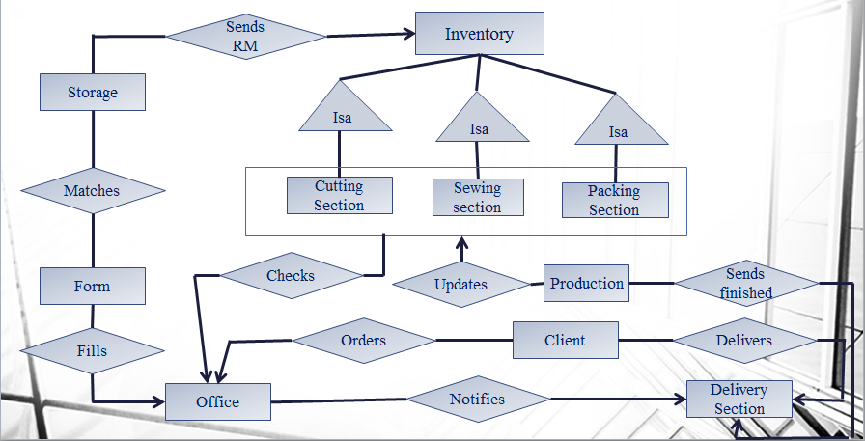

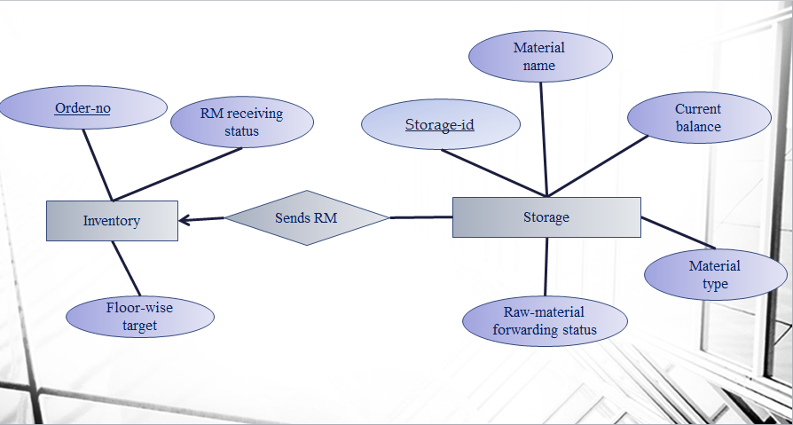

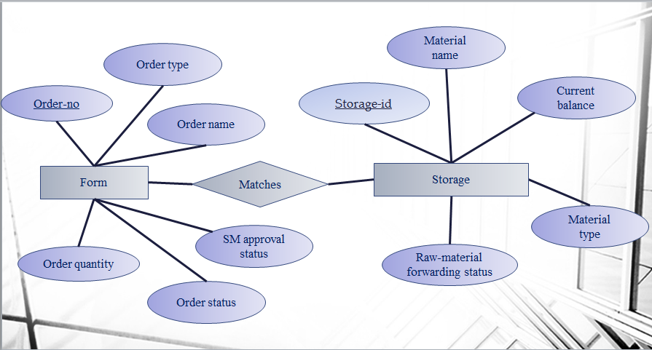

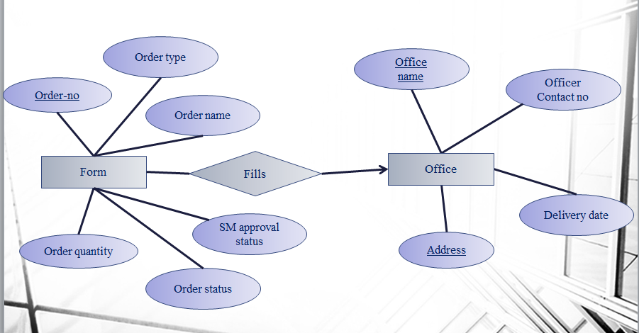

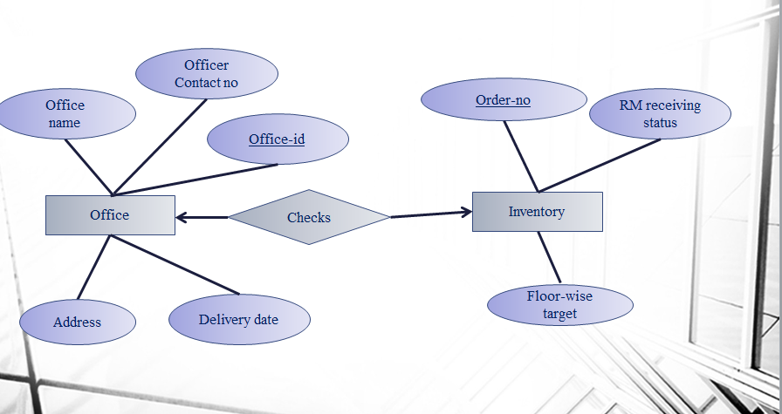



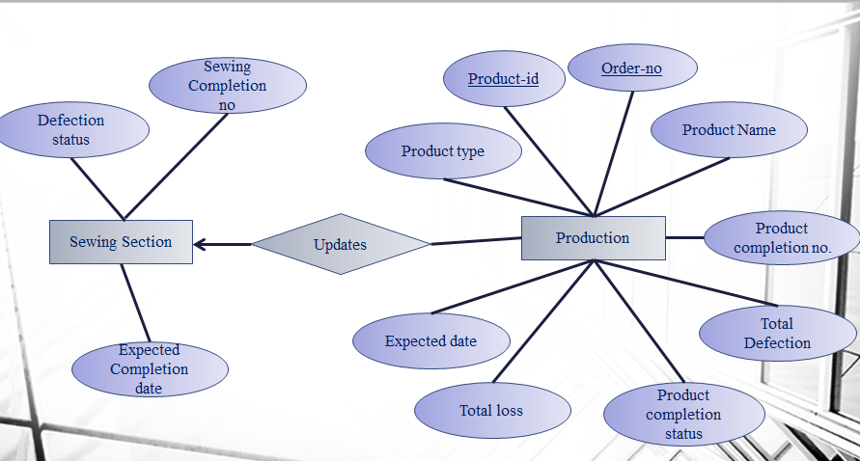

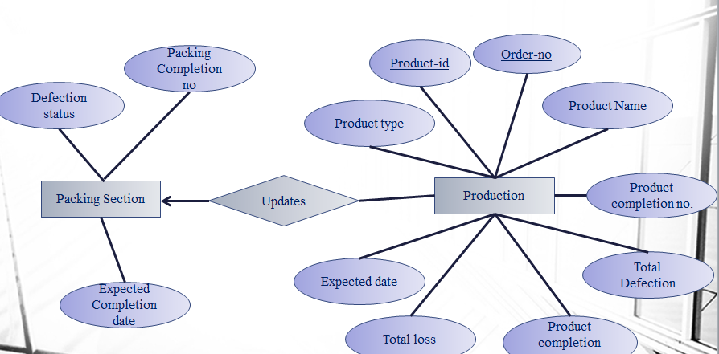

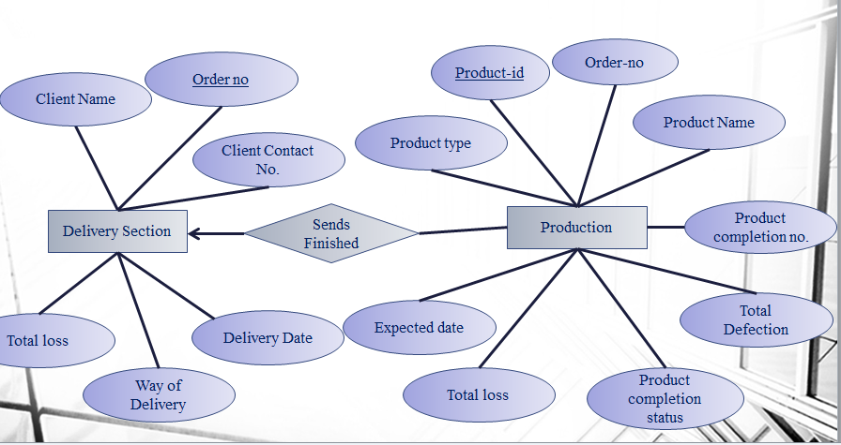

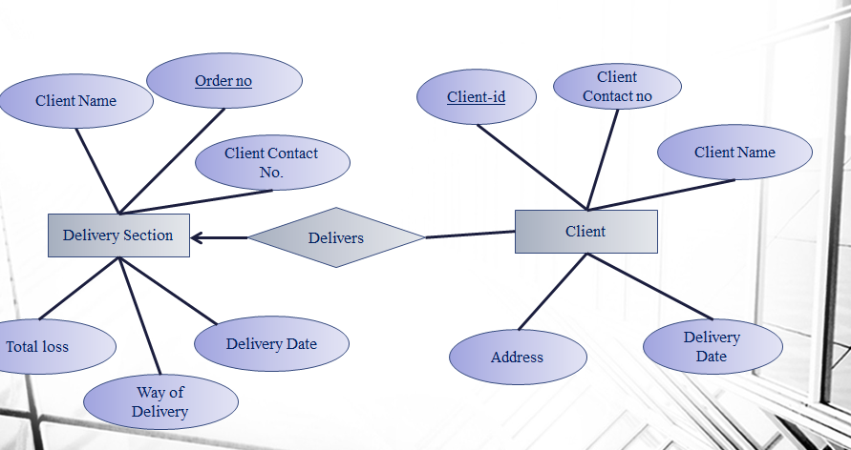

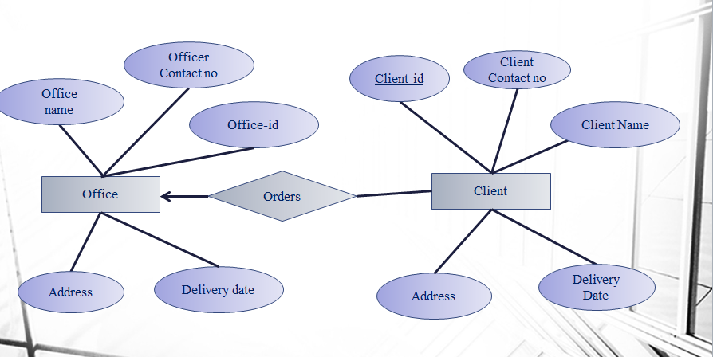

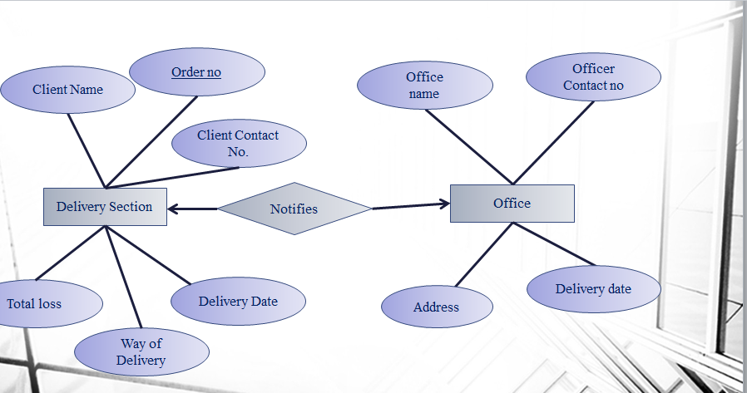

Form entity

|  |  |
| --- | --- |
| form | |
| Order no | Number |
| Order name | Varchar2(30) |
| Order quantity | Number |
| Order type | Varchar2(30) |
| Order status | Varchar2(30) |
| Sm approval status | Varchar2(30) |

­­­

Functions

|  |  |
| --- | --- |
| Function name | Get form |
| Time of execution | After the system starts |
| input |  |
| output | All the attributes of form |
| action | Select all attributes from form |

|  |  |
| --- | --- |
| procedure name | select form |
| Time of execution | After the user selects a form |
| input | Order no |
| output | Order type, order quantity, order status |
| action | select order no, order type , order quantity, order status from form |

|  |  |
| --- | --- |
| procedure name | confirm order |
| Time of execution | After the sm confirms the order |
| input | order no |
| output |  |
| action | Set order status to ‘approved’ |
|  |  |

|  |  |
| --- | --- |
| procedure name | Match form |
| Time of execution | After the user selects a form |
| input | Order no,order quantity |
| output |  |
| action | Call storage.match type(char), if match type returns true, call storage.match quantity(int), if match type returns false, set order status to ‘rejected’ if match quantity returns false ,set order status to rejected.’ |

Trigger:

|  |  |  |  |
| --- | --- | --- | --- |
| Trigger name | | | Update balance |
| Time of execution | | | After the **order status** attribute is updated to ‘approved’ |
| actions | | | remarks |
| commands | attributes | tables |  |
| Set status | Storage balance | storage | After the order has been confirmed change the storage balance (current balance= previous balance-order quantity) |

Storage entity:

|  |  |
| --- | --- |
| storage id | Number |
| material name | Varchar2(30) |
| current balance | Number |
| material type | Varchar2(30) |
| RM forwarding Status | Varchar2(30) |
|  |  |
|  |  |

|  |  |
| --- | --- |
| Function name | Match type |
| Time of execution | After the user selects a form |
| input | Order type |
| output | Boolean |
| action | Match the type of the order with storage |

|  |  |
| --- | --- |
| Function name | Match quantity |
| Time of execution | After the match type function has returned true |
| input | Order quantity |
| output | Boolean |
| action | Match the quantity of the order with storage |

|  |  |  |  |
| --- | --- | --- | --- |
| Trigger name | | | Update status 1 |
| Time of execution | | | When **match type**==’false’ |
| actions | | | remarks |
| commands | attributes | tables |  |
| Set status | Order status | form | If Match type = false, set order status to rejected |

|  |  |  |  |
| --- | --- | --- | --- |
| Trigger name | | | Update status 2 |
| Time of execution | | | When **Match quantity** ==’false’ |
| actions | | | remarks |
| commands | attributes | tables |  |
| Set status | Order status | form | If Match quantity = false, set order status to rejected |

|  |  |  |  |
| --- | --- | --- | --- |
| Trigger name | | | Update status 3 |
| Time of execution | | | When **match quantity**== true |
| actions | | | remarks |
| commands | attributes | tables |  |
| Set status | Order status | form | If Match quantity = true, set order status to waiting for approval |

Inventory

|  |  |
| --- | --- |
| product id | Number |
| Order no | Number |
| RM receiving status | Varchar2(30) |
| Floor wise target | number |

Inventory: cutting section

|  |  |
| --- | --- |
| inventory id | Number |
| cutting completion number | Number |
| Expected completion date | date |
| Defection count | Number |

|  |  |  |  |
| --- | --- | --- | --- |
| Trigger name | | | Update defection count 1 |
| Time of execution | | | After **defection count** has been updated |
| actions | | | remarks |
| commands | attributes | tables |  |
| Set status | Total defection | production | after updating defection count  production.total defection = total defection + Cutting Section defection count |

|  |  |
| --- | --- |
| Procedure name | Input cutting status |
| Time of execution | After the css presses the update cutting status button |
| input | Quantity of completed product in cutting section |
| output |  |
| action | Update the **‘cutting completion number’** attribute |
|  |  |

|  |  |
| --- | --- |
| procedure name | Input defection status |
| Time of execution | After the css presses update defection status report |
| input | defection quantity |
| output |  |
| action | Update the **defection count** attribute  **loss count**= loss count+ defection count / (cutting completion number+defection count) |
|  |  |

|  |  |
| --- | --- |
| Function name | View cutting status |
| Time of execution | After the MO presses the view cutting status button |
| input |  |
| output | Cutting status |
| action | Show the current **cutting completion number** |
|  |  |

Inventory: sewing section

|  |  |
| --- | --- |
| inventory id | Number |
| sewing completion number | Number |
| Expected completion date | Date |
| Defection count | Number |

|  |  |
| --- | --- |
| Procedure name | Input sewing status |
| Time of execution | After the sss presses the update cutting status button |
| input | Quantity of completed product in cutting section |
| output |  |
| action | Update the ‘**sewing completion number’** attribute |
|  |  |

|  |  |
| --- | --- |
| procedure name | Input defection status |
| Time of execution | After the sss presses update defection status report |
| input | defection quantity |
| output |  |
| action | Update the **defection count** attribute  **loss count**= loss count+ defection count / (sewing completion number+defection count) |
|  |  |

|  |  |
| --- | --- |
| Function name | View sewing status |
| Time of execution | After the MO presses the view cutting status button |
| input |  |
| output | sewing completion number |
| action | Show the current **sewing completion number** |
|  |  |

|  |  |  |  |
| --- | --- | --- | --- |
| Trigger name | | | Update defection count 2 |
| Time of execution | | | After **defection count attribute** has been updated |
| actions | | | remarks |
| commands | attributes | tables |  |
| Set status | Total defection | production | after updating defection count  production.total defection = total defection + sewing Section defection count |

Inventory: packing section

|  |  |
| --- | --- |
| inventory id | Number |
| Packing completion number | Varchar2(30) |
| Expected completion date | Date |
| Defection count | Number |

|  |  |
| --- | --- |
| Procedure name | Input packing status |
| Time of execution | After the pss presses the update packing status button |
| input | Quantity of completed product in packing section |
| output |  |
| action | Update the ‘**packing completion number’** attribute |
|  |  |

|  |  |
| --- | --- |
| procedure name | Input defection status |
| Time of execution | After the pss presses update defection status report |
| input | defection quantity |
| output |  |
| action | Update the **defection count** attribute  **loss count**= loss count+ defection count / (packing completion number+defection count) |
|  |  |

|  |  |
| --- | --- |
| Function name | View packing status |
| Time of execution | After the MO presses the view packing status button |
| input |  |
| output | packing completion number |
| action | Show the current **packing completion number** |
|  |  |

|  |  |  |  |
| --- | --- | --- | --- |
| Trigger name | | | Update defection count 3 |
| Time of execution | | | After the **defection count** has been updated |
| actions | | | remarks |
| commands | attributes | tables |  |
| Set status | Total defection | production | after updating defection count  production.total defection = total defection + packing Section defection count  production.total loss= total loss + total defection / (packing completion number+total defection ) |

|  |  |  |  |
| --- | --- | --- | --- |
| Trigger name | | | Update completion status |
| Time of execution | | | After **packing completion number** has been updated |
| actions | | | remarks |
| commands | attributes | tables |  |
| Set status | Total defection | production | production. Production completion number= packing completion number |

Production:

|  |  |
| --- | --- |
| product id | number |
| Order no | number |
| Product name | Varchar2(30) |
| Product type | Varchar2(30) |
| Production completion number | Number |
| Production completion status | Varchar2(30) |
| Expected date | Date |
| Total defection | Number |
| Total loss | Number |

|  |  |
| --- | --- |
| Procedure name | Input production status |
| Time of execution | After the pss presses the update cutting status button |
| input | Quantity of completed product in packing section |
| output |  |
| action | Update the ‘**production completion number** attribute |
|  |  |

|  |  |
| --- | --- |
| Function name | View production status |
| Time of execution | After the MO presses the view production status button |
| input |  |
| output | Production completion number |
| action | Show the current **production completion number** |
|  |  |

|  |  |
| --- | --- |
| Function name | View defection status |
| Time of execution | After the MO presses the view defection status button |
| input |  |
| output | Total defection |
| action | Show the **total defection** |
|  |  |

|  |  |  |  |
| --- | --- | --- | --- |
| Trigger name | | | Update production count |
| Time of execution | | | After **production completion status** is updated to ‘completed’ |
| actions | | | remarks |
| commands | attributes | tables |  |
| Set status | Delivery status | Delivery section | update delivery.delivery status= "ready for delivery" |

Delivery section:

|  |  |
| --- | --- |
| Order no | Number |
| client name | Varchar2(30) |
| Client contact no | Number |
| Delivery method | Varchar2(30) |
| delivery date | Date |
| Total loss | Number |

|  |  |
| --- | --- |
| Function name | confirm shipment method |
| Time of execution | After the client presses the confirm button |
| input | Delivery date, delivery method |
| output |  |
| action | Set the **delivery date, delivery method** set **delivery status** to ‘processing’ |
|  |  |

|  |  |
| --- | --- |
| Function name | confirm delivery |
| Time of execution | After the client presses the received button |
| input |  |
| output |  |
| action | Set the **delivery status** to ‘delivered’ |
|  |  |

|  |  |  |  |
| --- | --- | --- | --- |
| Trigger name | | | Update delevery completion status |
| Time of execution | | | After **delivery status** is set to ‘delivered’ |
| actions | | | remarks |
| commands | attributes | tables |  |
| Set status |  | delivery | update production.production completion status="delivered" |

Office

|  |  |
| --- | --- |
| Officer id | Number |
| Officer name | Varchar2(30) |
| Officer contact no | Number |
| delivery date | Date |
| address | Varchar2(30) |

Client

|  |  |
| --- | --- |
| client id | Number |
| Client name | Varchar2(30) |
| client contact no | Number |
| delivery date | Date |
| address | Varchar2(30) |